- Create one jenkins job using the below code and create three stages.

stage1: Git clone to download the source code.
stage2: Sonarqube Integration to check the quality of code
stage3: Slack Integration to send the alerts to slack.
URL: https://github.com/betawins/VProfile-1.git

Stage 1 : To clone the source code :

Create jenkins job - freestyle , add repository url in source code management ,
Also pass credentials if repository is private , if public not neccesary . and also branch specifier
( /main or /master ).

Save .

Build job manually.

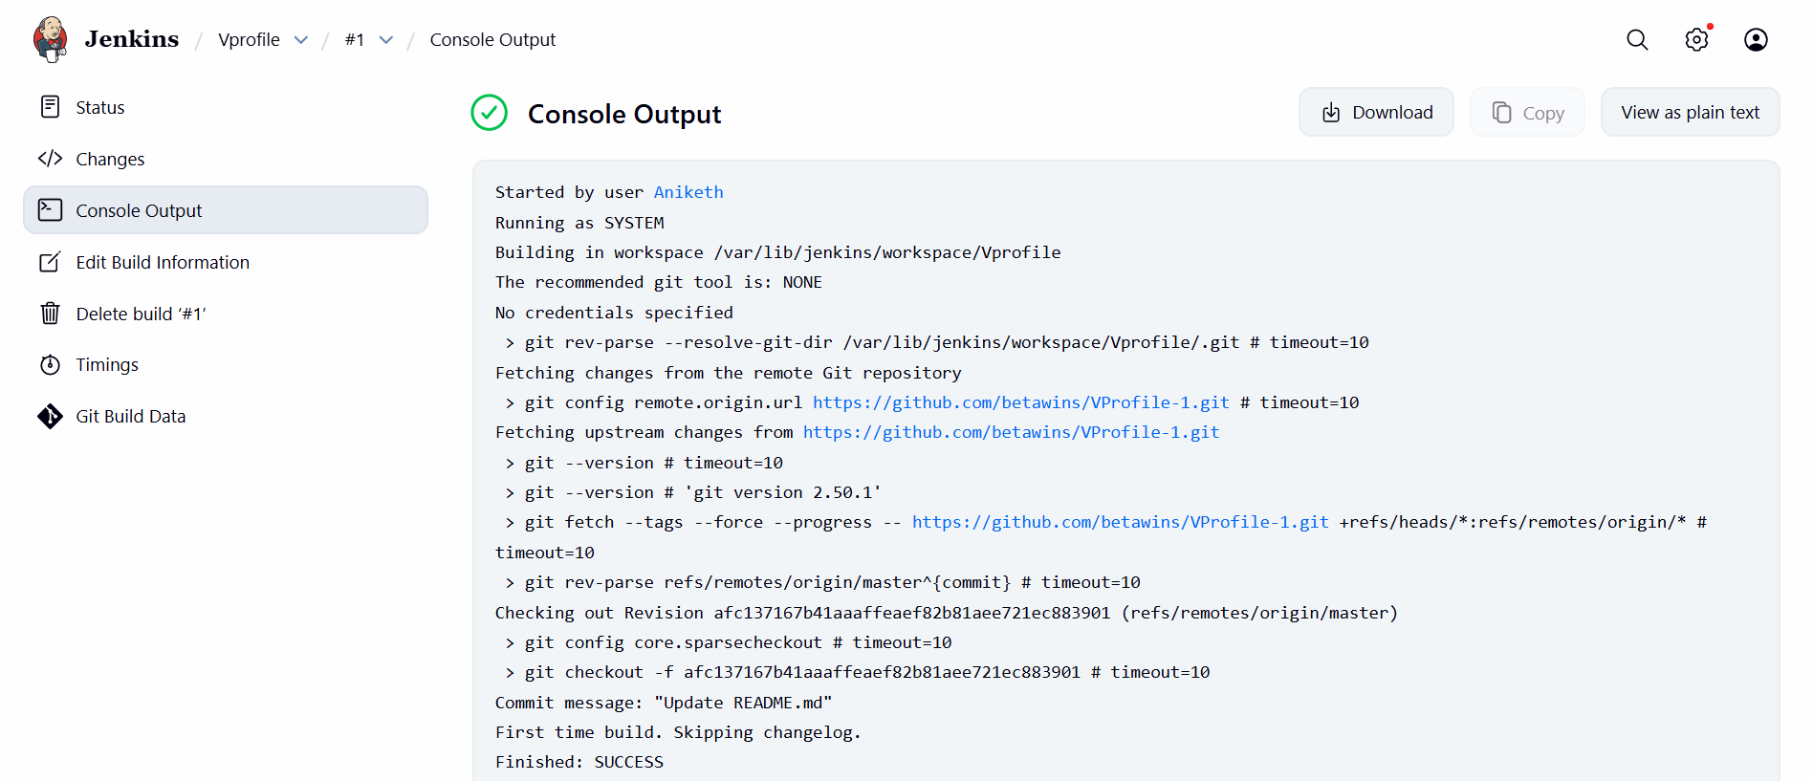

Stage 2 : Sonarqube integration to check the quality of code :

Steps for sonarqube install and integrate.

## 1. launch ec2 with large instance type , and configure storage of 20 gb , open ports 22 for ssh , 9000 for sonarqube , 5432 for postgresSQL

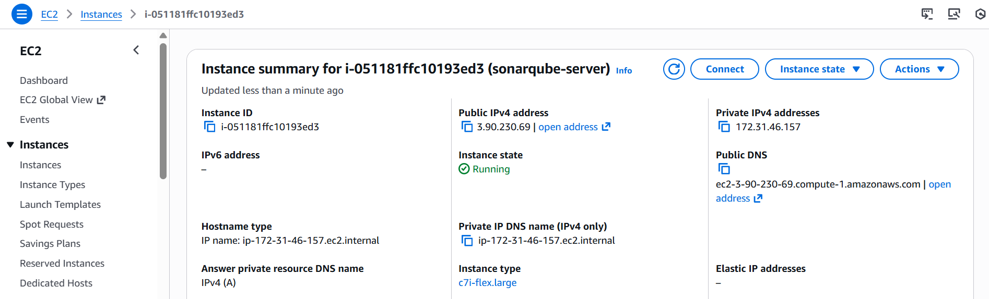

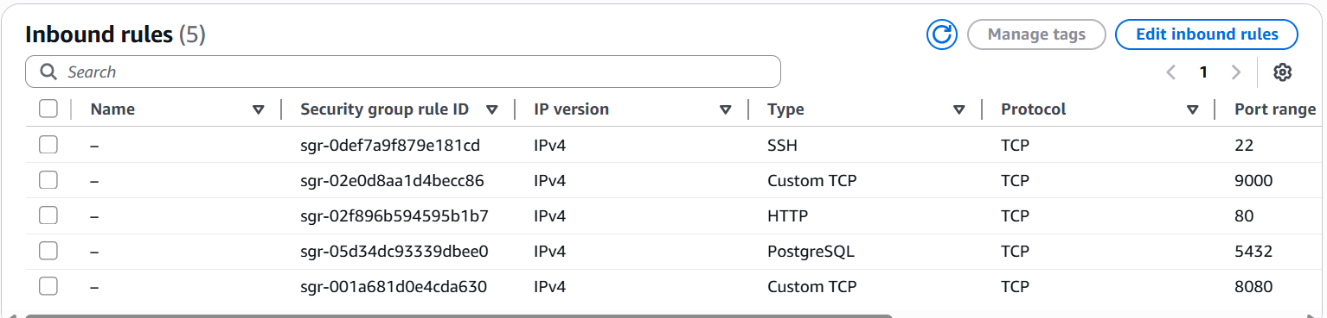

## 2. launch the sonarqube server :

ssh -i "western.pem" ec2-user@ec2-3-90-230-69.compute-1.amazonaws.com

## 3. install java latest version :

sudo yum update -y
sudo dnf install java-17-amazon-corretto -y
java -version

## 4. install postgreSQL

sudo dnf install postgresql15-server postgresql15-contrib -y

Initial the database :
sudo postgresql-setup --init
sudo sysctl -w vm.max_map_count=262144
sudo sysctl -w fs.file-max=65536
echo "vm.max_map_count=262144" | sudo tee -a /etc/sysctl.conf
echo "fs.file-max=65536" | sudo tee -a /etc/sysctl.conf
sudo sysctl -p
sysctl vm.max_map_count
sysctl fs.file-max

systemctl start postgresql.service
systemctl status postgresql.servic

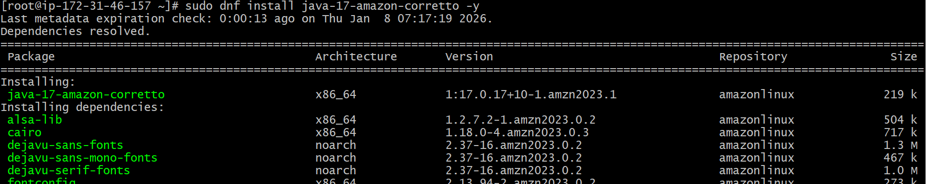

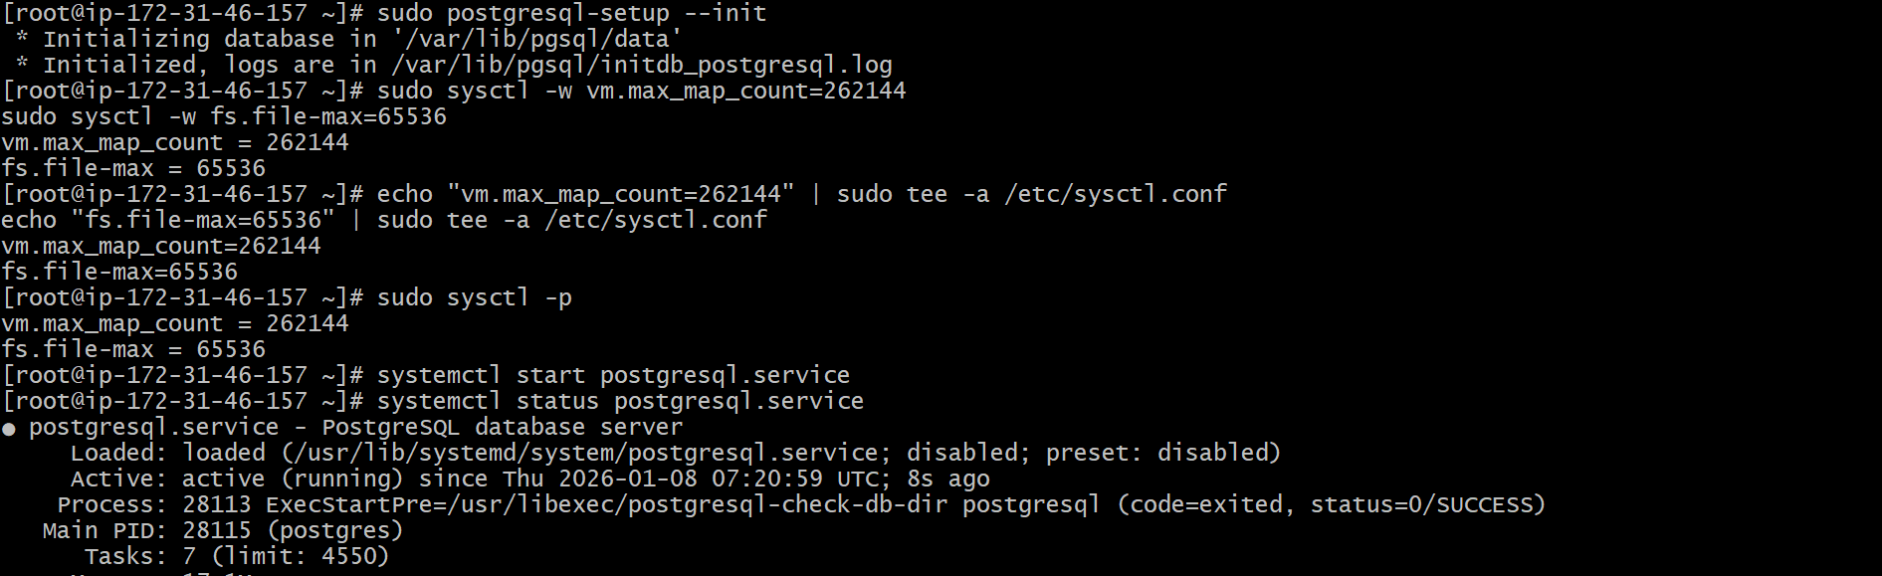

Login to postgresql and create database :

su - postgres (or) psql -U postgres -h localhost
psql

CREATE DATABASE sonarqube;
CREATE USER sonar WITH PASSWORD 'sonar@123';
GRANT ALL PRIVILEGES ON DATABASE sonarqube TO sonar;
ALTER DATABASE sonarqube OWNER TO sonar;
ALTER USER postgres WITH PASSWORD 'postgres';
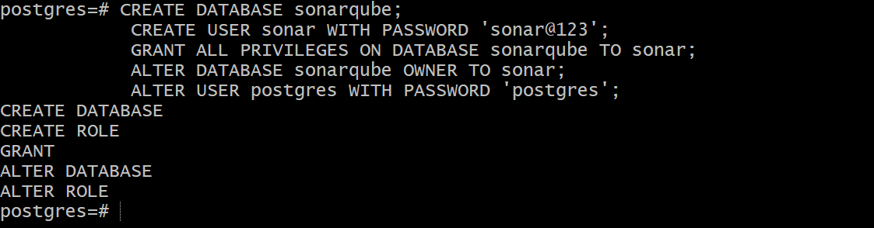

Check whether database created :

\list == to check databases
\q == to exit from postgres
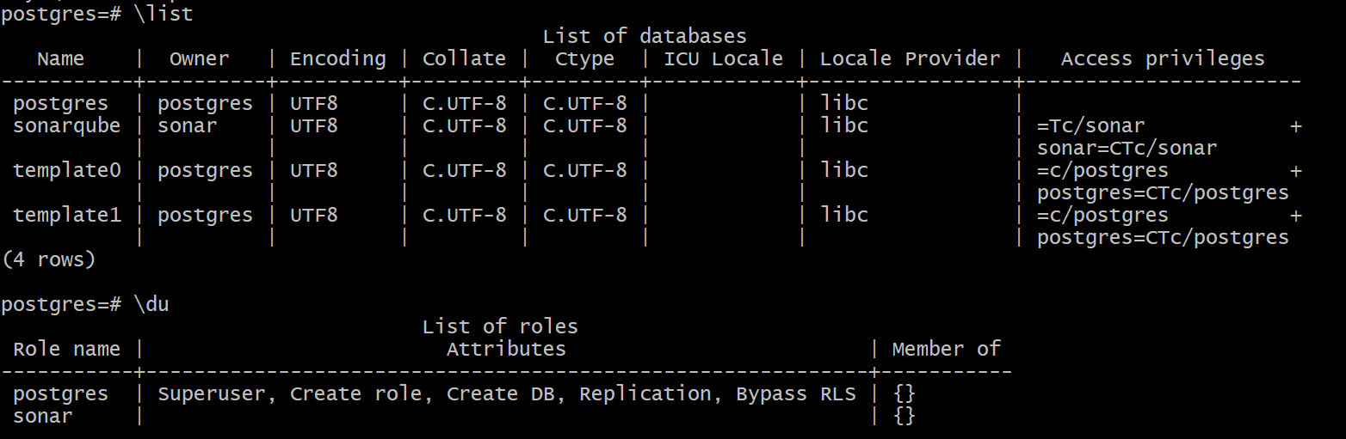

Exit from postgres.

sudo find /var/lib/pgsql -name pg_hba.conf === in this change all to md5 from ident

local all postgres md5
host all all 127.0.0.1/32 md5

sudo systemctl restart postgresql
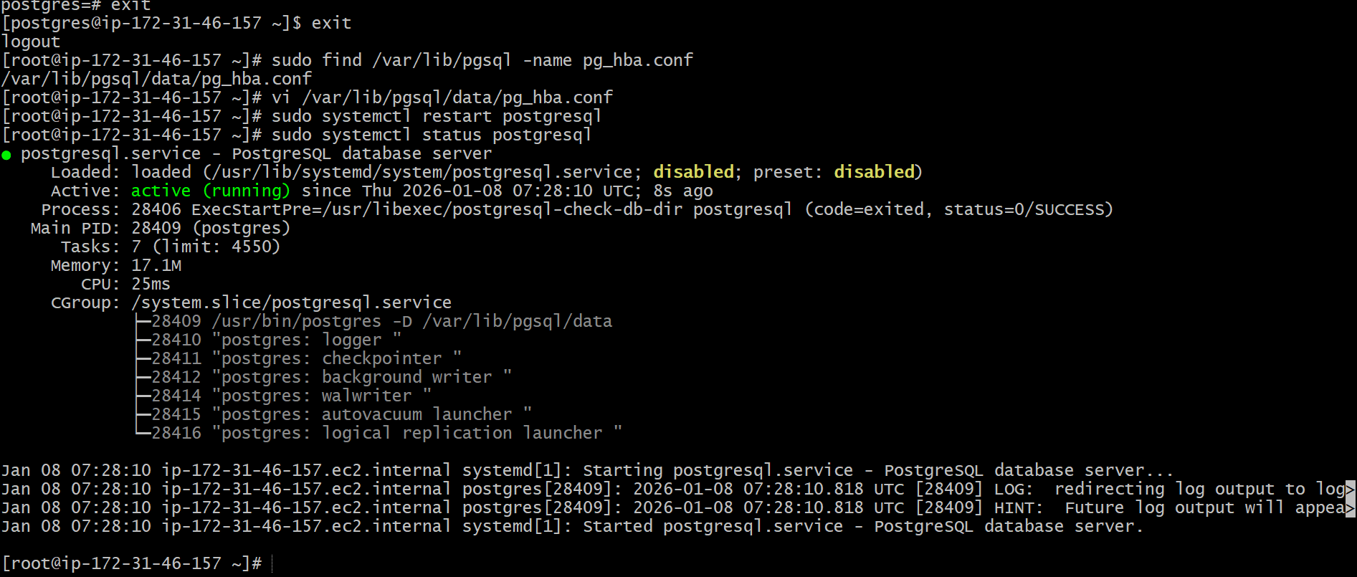

## 5. install sonarqube in /opt

cd /opt
sudo yum install wget unzip -y
sudo wget https://binaries.sonarsource.com/Distribution/sonarqube/sonarqube-9.9.3.79811.zip
sudo unzip sonarqube-9.9.3.79811.zip
sudo mv sonarqube-9.9.3.79811 sonarqube

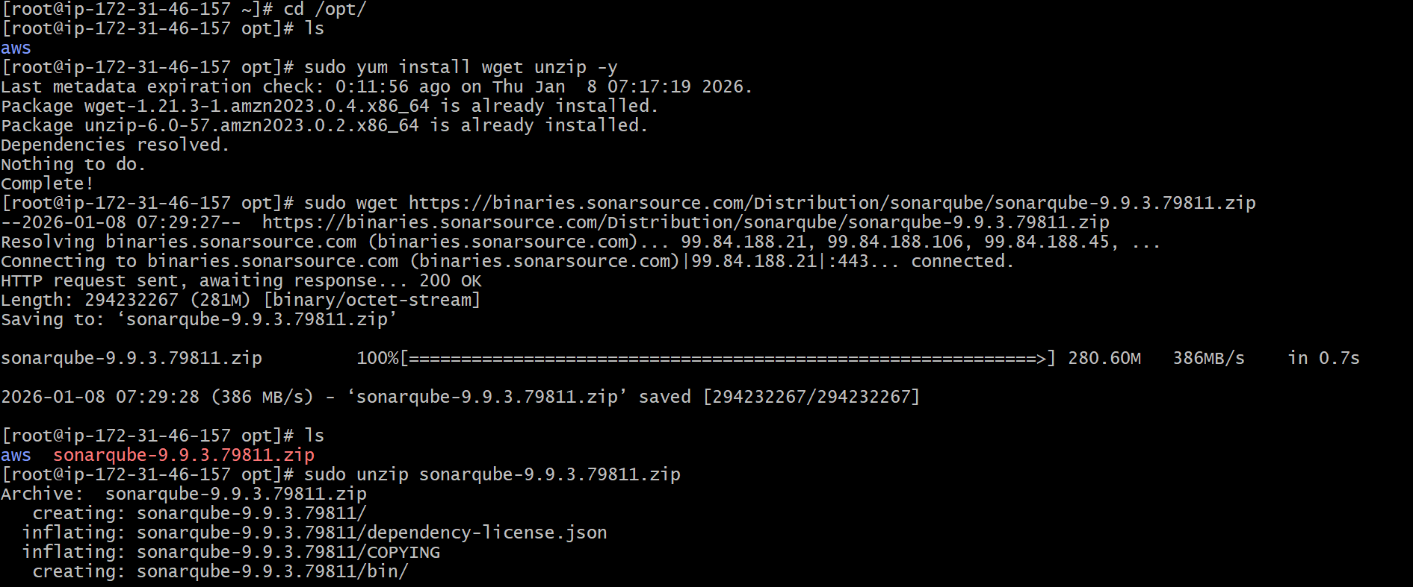
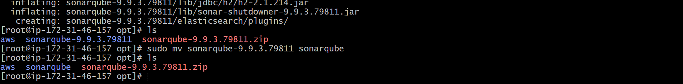

## 6. change sonar.properties : at == /sonarqube/conf/sonar.properties

Change user credentials , add which are created in postgresql.
Remove the “#” from the lines

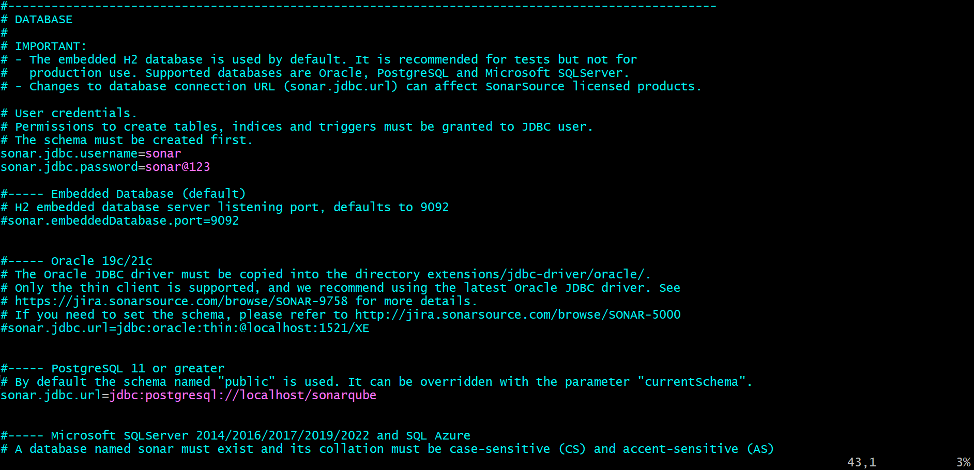
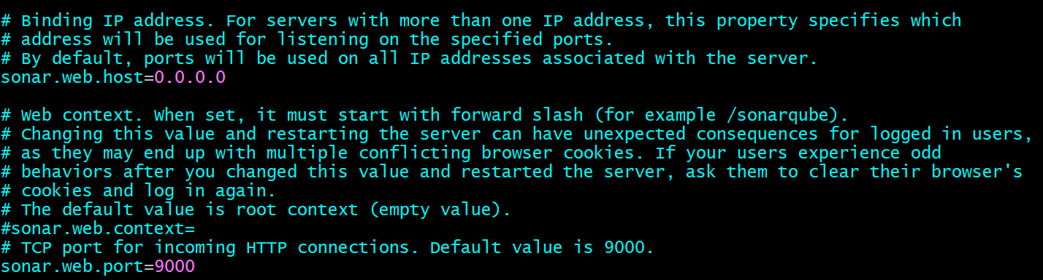

Also remove “?currentSchema=my_schema”

at sonar.jdbc.url=jdbc:postgresql://localhost/sonarqube?currentSchema=my_schema

Save and exit.

## 7. create user sonar and ownership to sonarqube , switch to that user and we can start sonar.
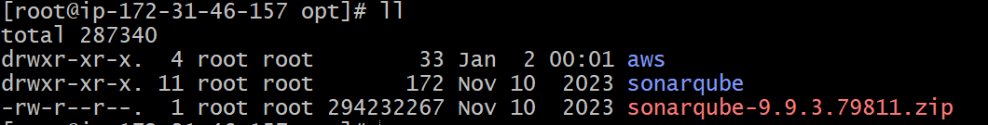

sudo useradd sonar
sudo passwd sonar
sudo chown -R sonar:sonar /opt/sonarqube

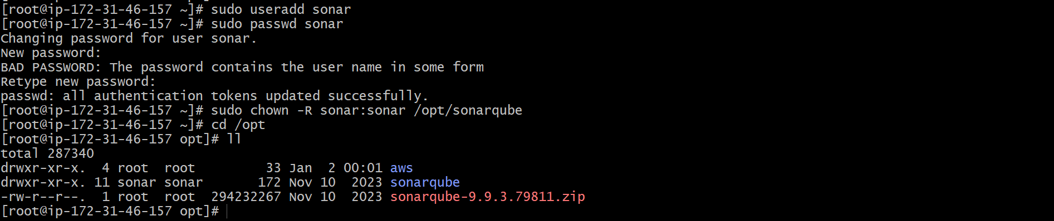

sudo vi /etc/sudoers.d/sonar
>>> sonar ALL=(ALL) NOPASSWD:ALL
sudo chmod 440 /etc/sudoers.d/sonar

Adding user sonar to sudoers file ,,

Switch to user “sonar” and start sonarqube
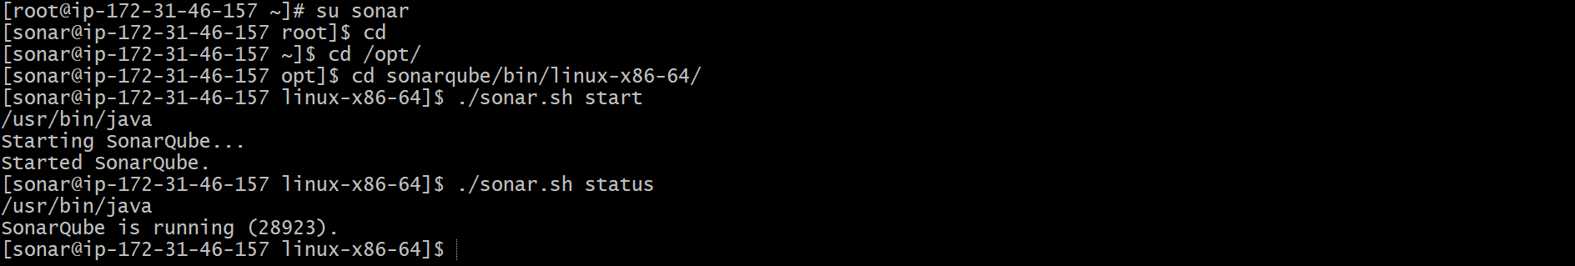

Succesfully sonarqube is running.

## 8. login to sonarqube server :

Ip of sonarqube-server:9000
Default username and password for sonarqube is “admin”
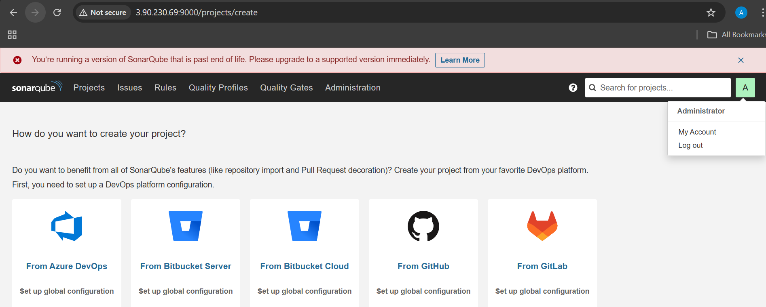

## 9. Generate sonarqube token :

My account > security > global token

sqa_82ee4e1c5526a2b67c21dc2b4fea6d4a312c6166

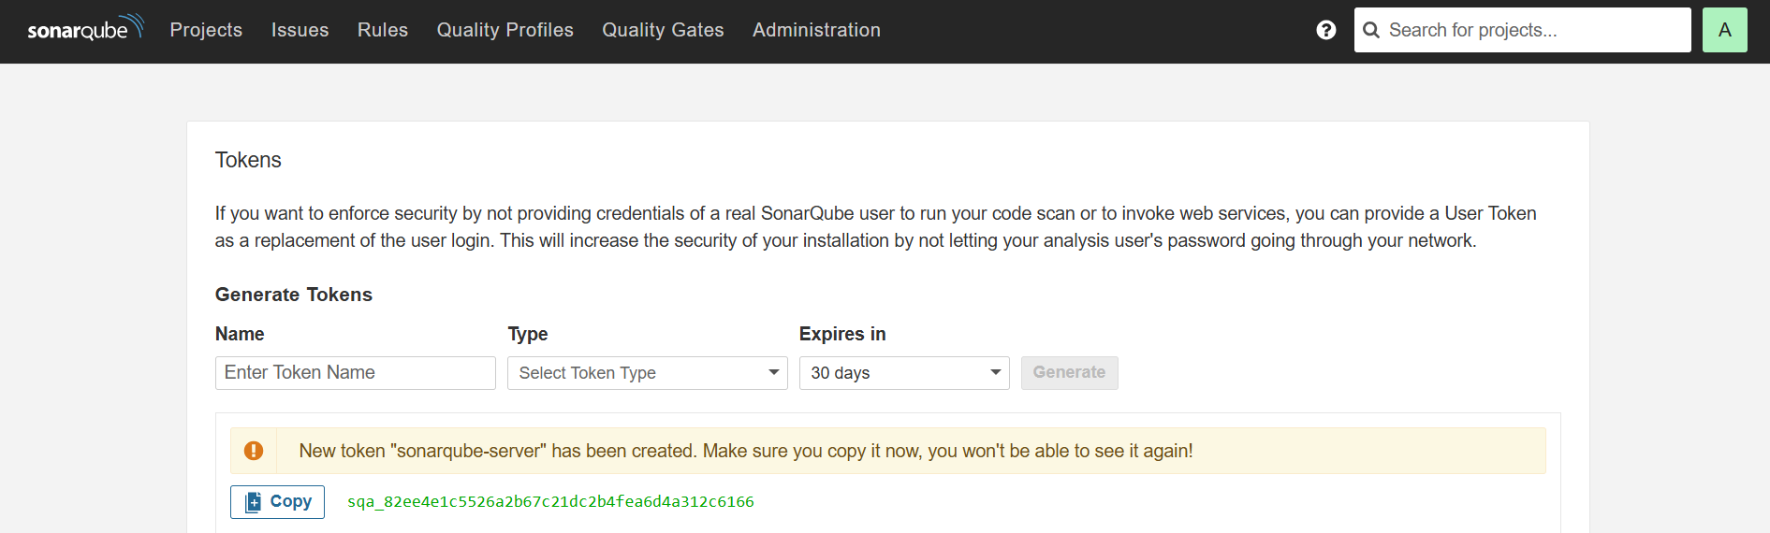

## 10. Add this token in jenkins credentials :

Manage jenkins > credentials > global > add credential
Select kind as “secret text “ paste the token created in secret

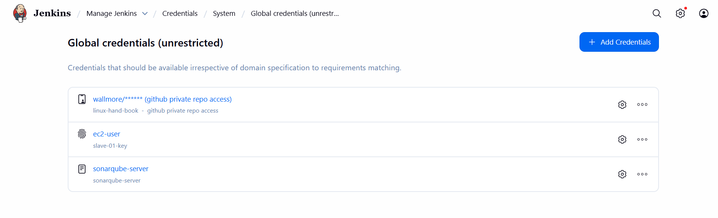
## 11. In Jenkins gui , install plugin “sonarqube scanner” :

Manage jenkins > system > add sonarqube

Add name and server url , server authentication token from cre

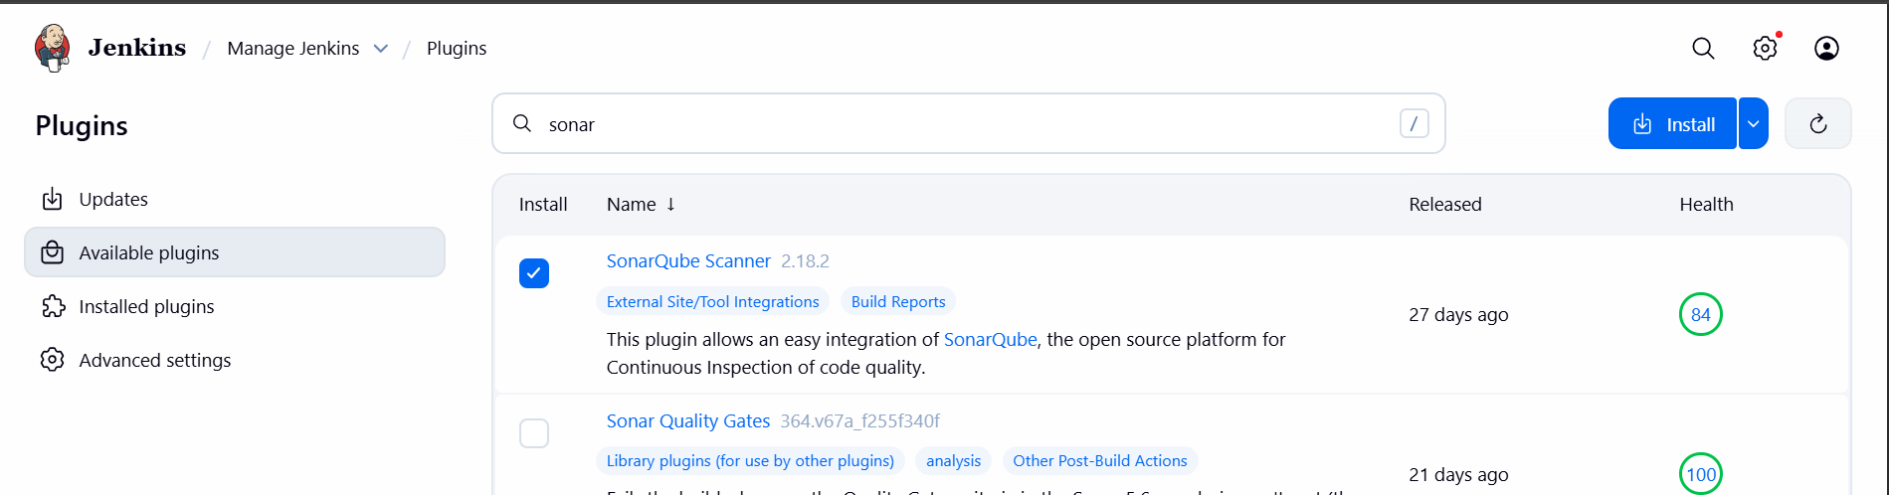

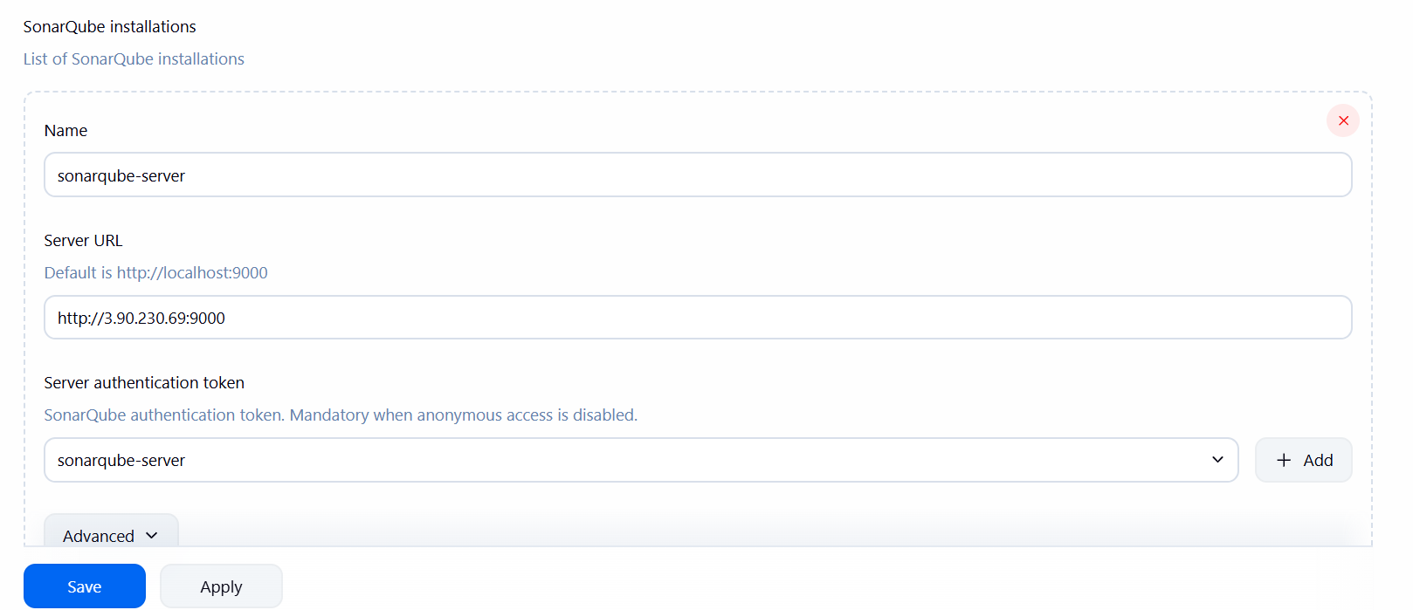

## 12. install sonar scanner on jenkins server :

cd /opt
sudo yum install -y unzip
sudo wget https://binaries.sonarsource.com/Distribution/sonar-scanner-cli/sonar-scanner-cli-5.0.1.3006-linux.zip
sudo unzip sonar-scanner-cli-5.0.1.3006-linux.zip
sudo mv sonar-scanner-5.0.1.3006-linux sonar-scanner
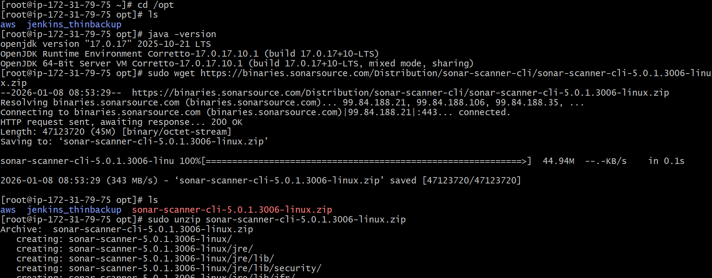
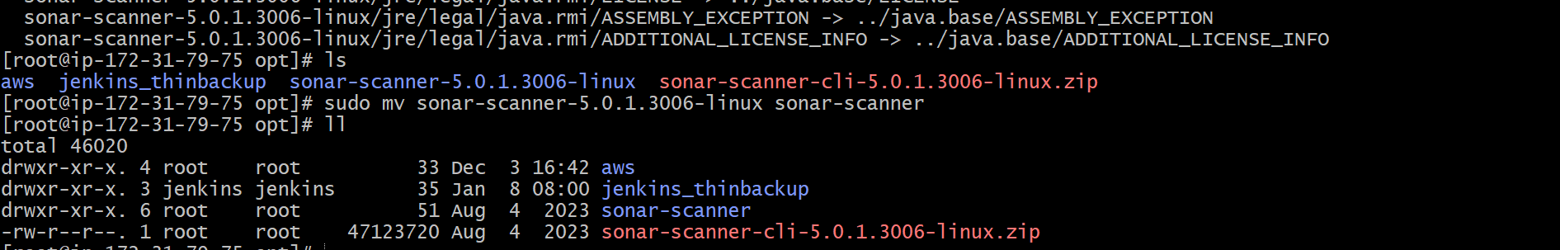

Now change the config file of sonar-scanner

Cd /sonar-scanner/conf/sonar-scanner properties

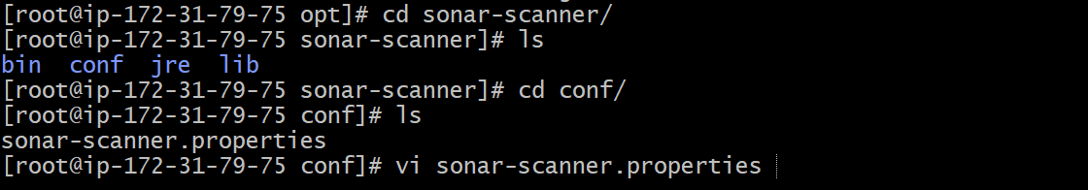

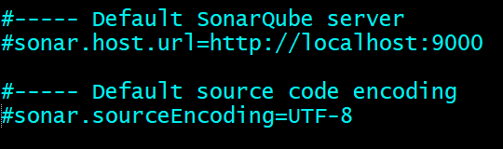

Add the url of sonarqube server and remove # in both lines

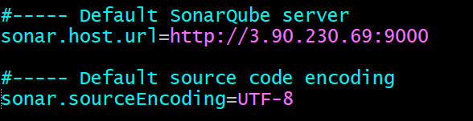

## 13. In Jenkins gui :
Manage jenkins > tools > sonar-scanner
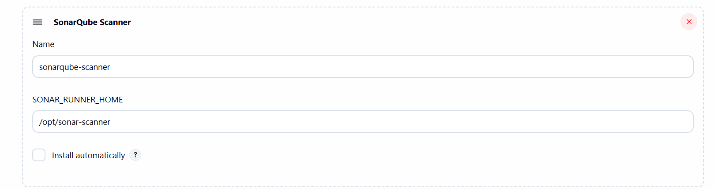
Save and exit.

## 14. configure sonarqube for job :

Select the job created > configure > build steps > execute sonarqube-scanner

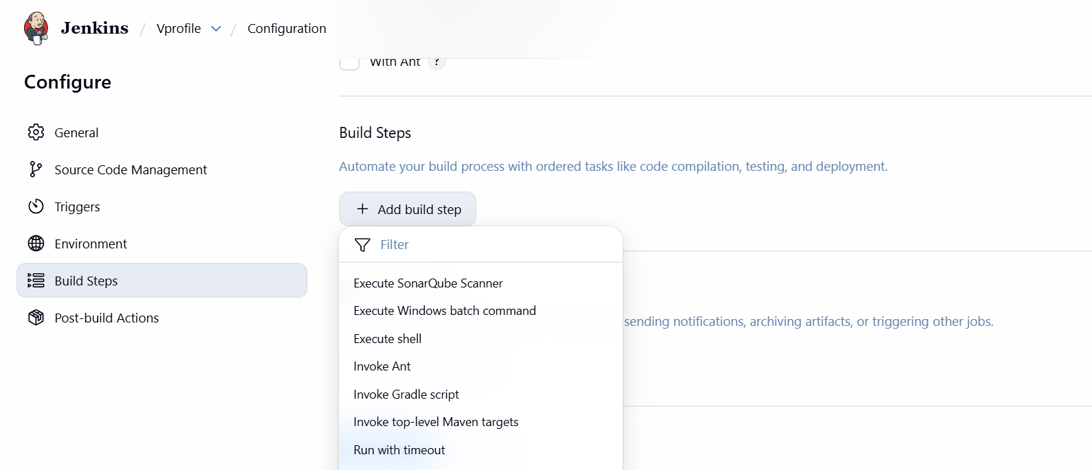

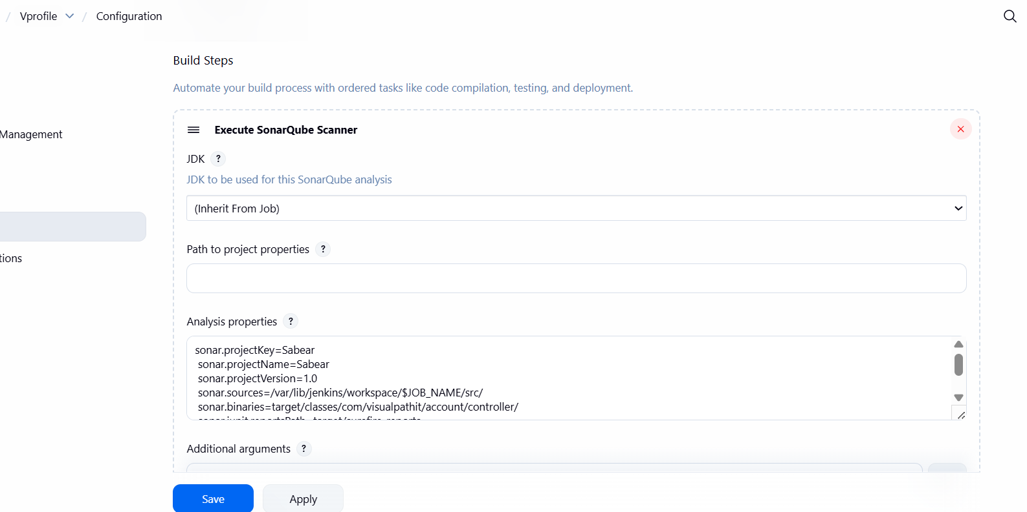

Paste the analysis properties from readme.md.

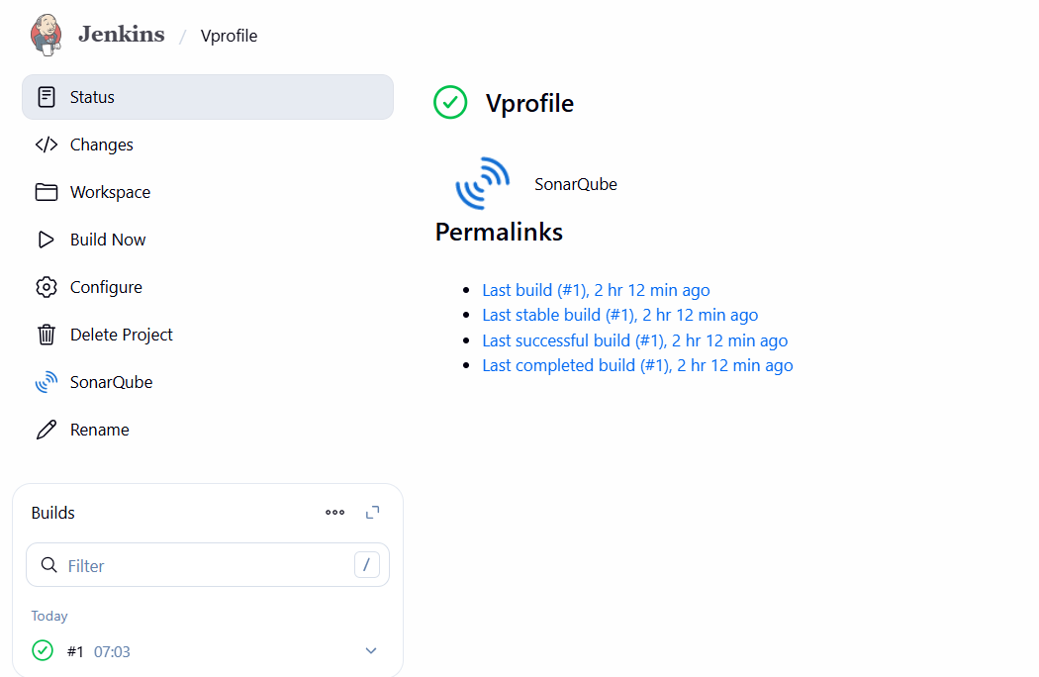

Build the job.

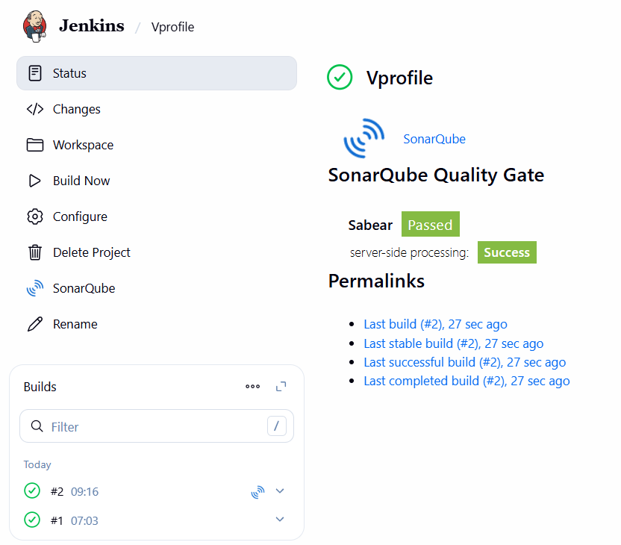

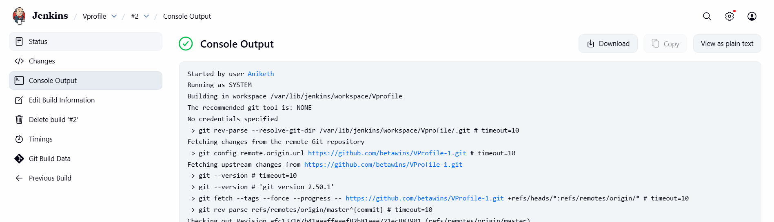
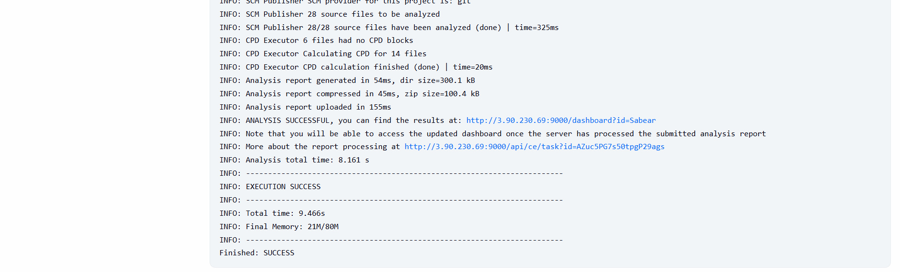

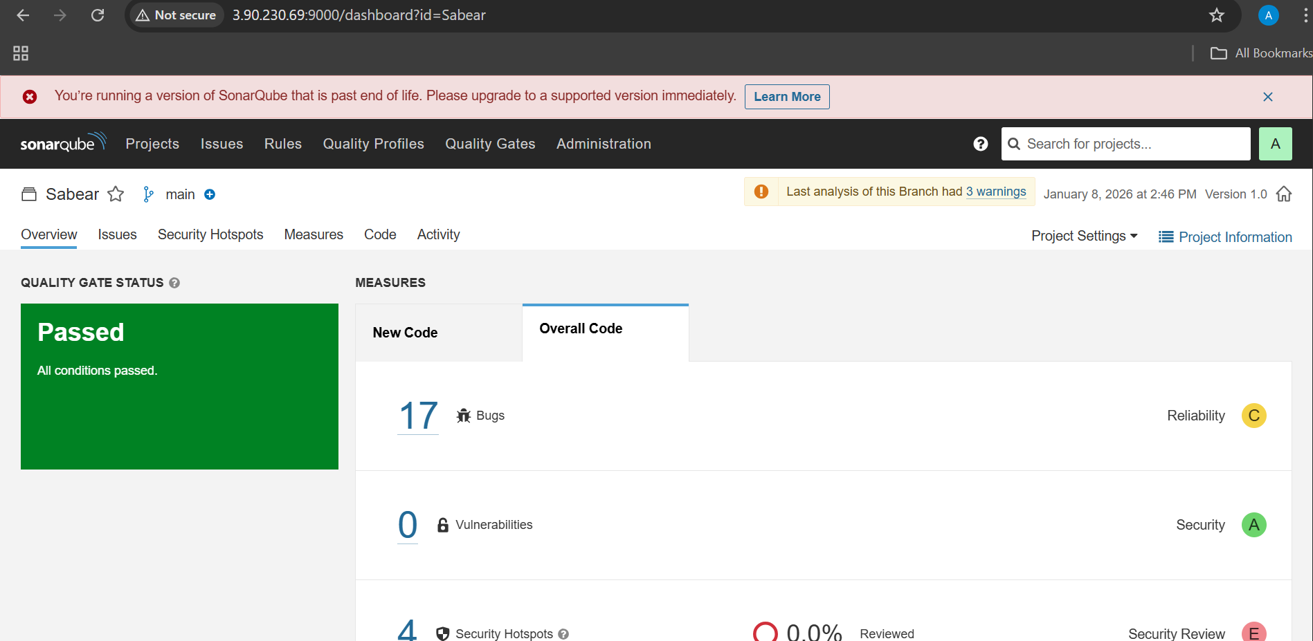

stage3: Slack Integration to send the alerts to slack.

##1. In jenkins install plugin “global slack notifier”

Go to slack in browser >> more>> tools>> apps >> jenkins ci >> configure >> add to post channel

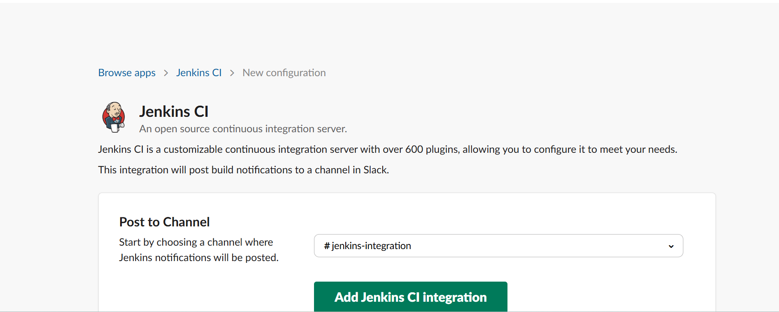

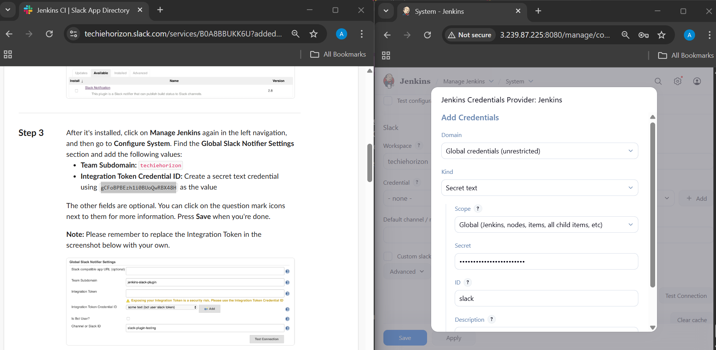

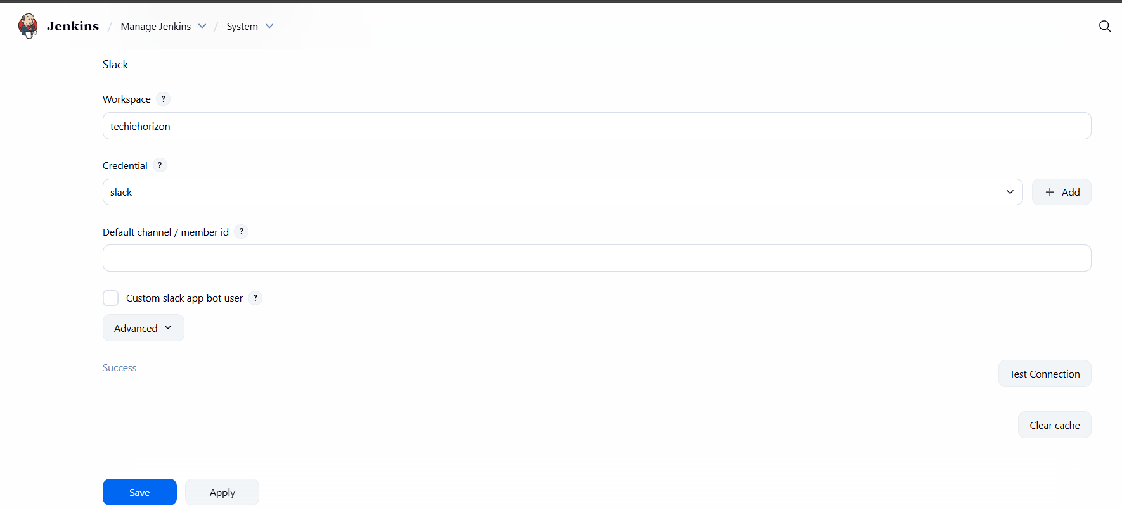

In job configure >> post build actions >> slack notification

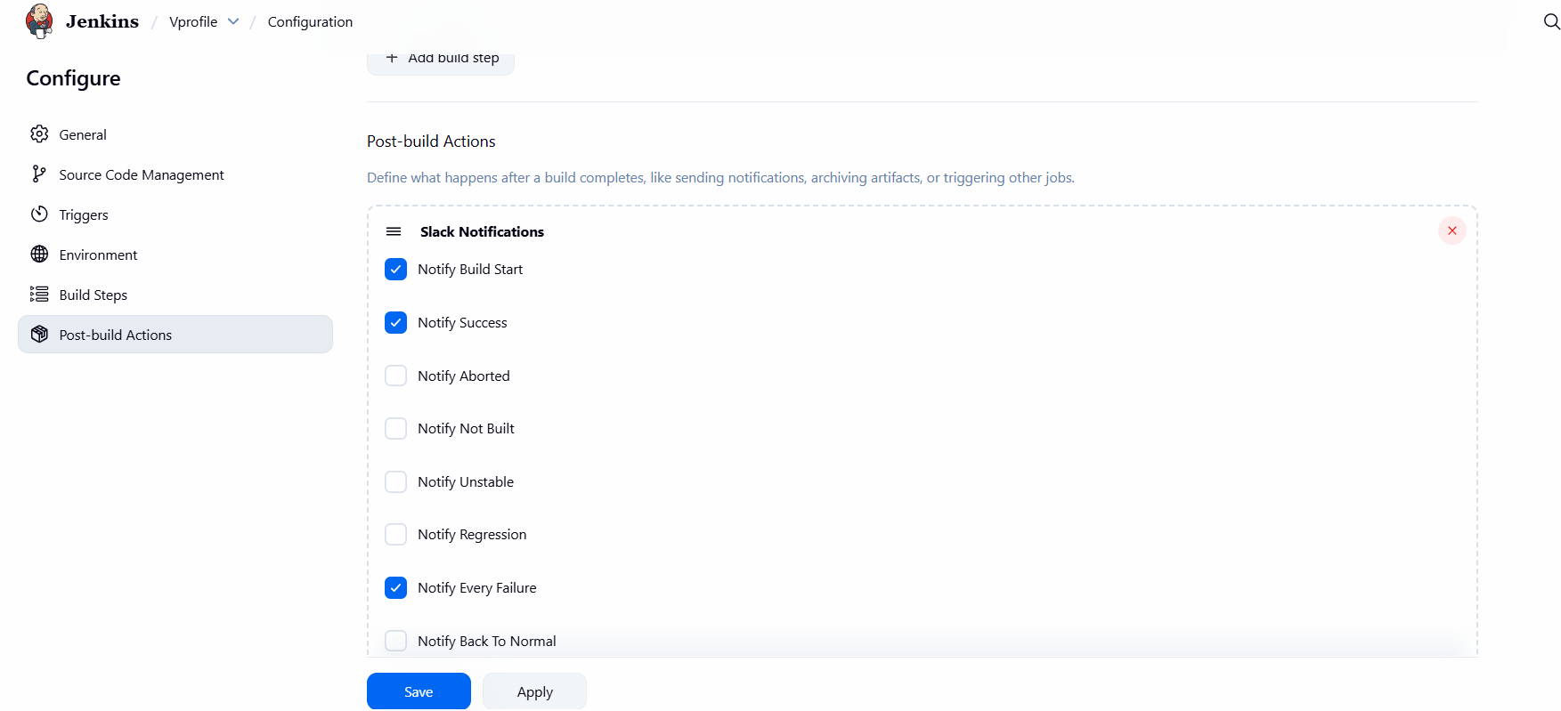

Succesfully slack notifications jenkins integration done.

- Create one jenkins job using the below code and create three stages.

stage1: Git clone to download the source code.
stage2: Sonarqube Integration to check the quality of code
stage3: Slack Integration to send the alerts to slack.
URL: https://github.com/betawins/hiring-app.git

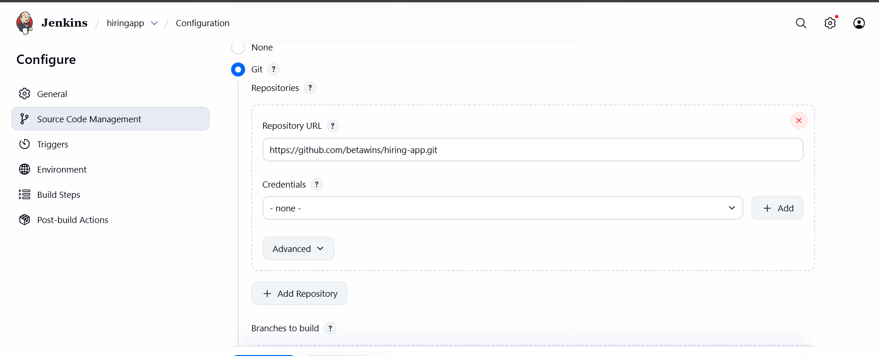
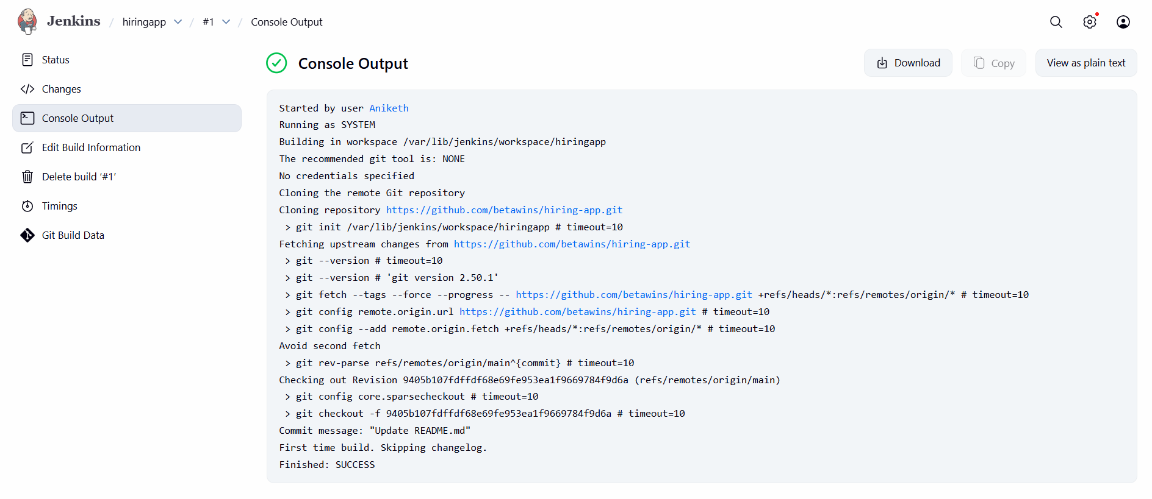

Stage 2 : code quality check

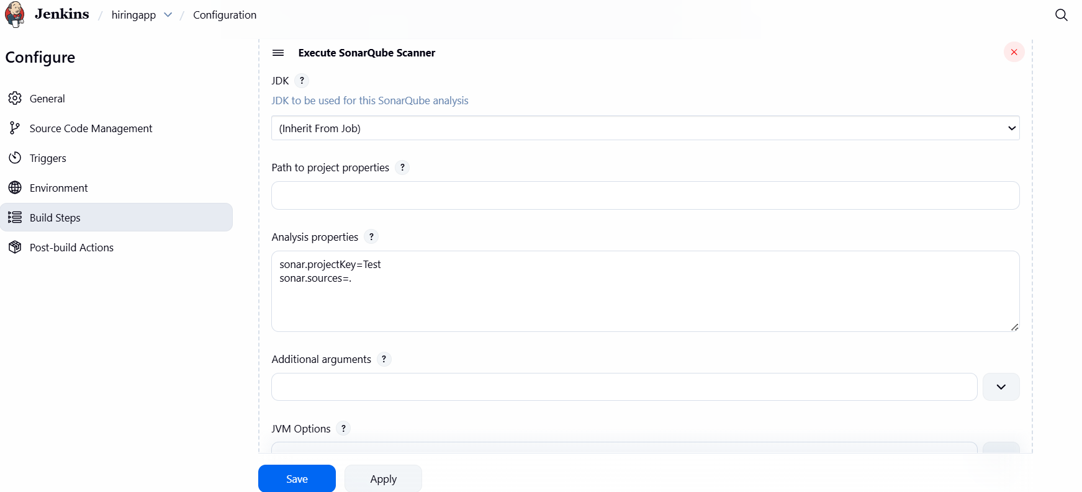

Stage 3 : slack alert notification.
